|  |
| --- |
| **National University of Computer and Emerging Sciences** |
| In Lab Exercise 5  “Aggregation And Nested Queries” |
|  |
| Database Systems |
| Spring 2018 |

Department of Computer Science

FAST-NU, Lahore, Pakistan

# Exercise

For this exercise use the following schema, the script to create this schema and populate data is given in Twitter.SQL file.

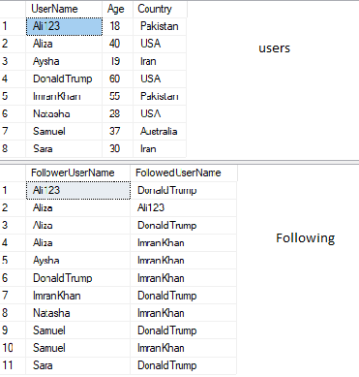

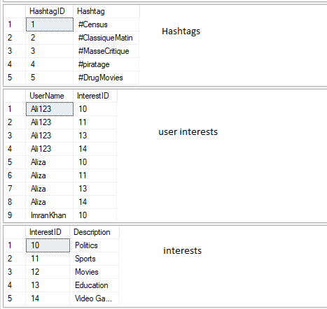

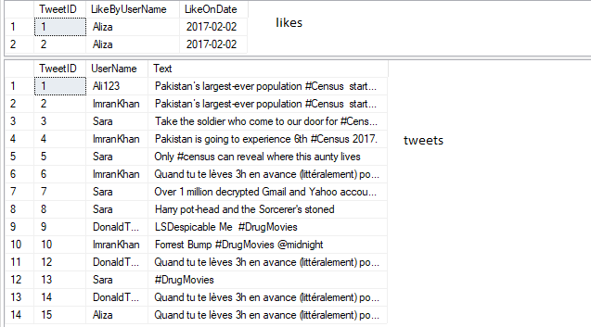

1. List all the user names and the number of tweets they have made till now.
2. What is Maximum and Minimum and average and standard deviation of ages of the users? (Search Standard Dev function from help or internet)
3. Give name of the user who has most followers.
4. Give name if the user who has second highest followers.
5. List names of all the users who have tweeted more than once
6. List total number of tweets per country with their tweet id list should be in order of country name and then tweet id
7. List all the hashtags and usernames and number of times that user used that hashtag.
8. List all the usernames that have never been followed. Using Set operation
9. List all the usernames that have never been followed. Using Exist Clause.
10. Show count of all the users with Name not starting from A
11. Show total tweets of each country.